Project Implementation Plan

Table of Contents

Proposal 1

Project Structure 1

Schedule 1

Phases 1

Development 1

Risks 1

# Proposal

Our goal is to make a game of Chinese Checkers. The game will support 2-6 players who can play over a network connection. Time permitting, we will also include a simple computer-controlled player.

# Project Structure

Our team is: Hans Gunther, David Griffin, Francisco Arrieta, Zachariah Yoshikawa, Ben Gibbons, and Matthew Booth. Everyone will contribute to writing code and designing features. The following special assignments have been made:

Project Manager: Hans Gunther

* Oversees project and helps keep team on schedule.

Git Lord: Francisco Arrieta

* Manage Github repo

Design Guru: David Griffin

* Lead design of software

Super Senior Software Sensei: Ben Gibbons

* Versatile code writer

Bug Insertion Specialist: Matthew Booth

* Versatile code writer and coffee coinsurer

Software Engineer Intern (unpaid): Zachariah Yoshikawa

* Design, de-bug, and implement features for the project

# Schedule

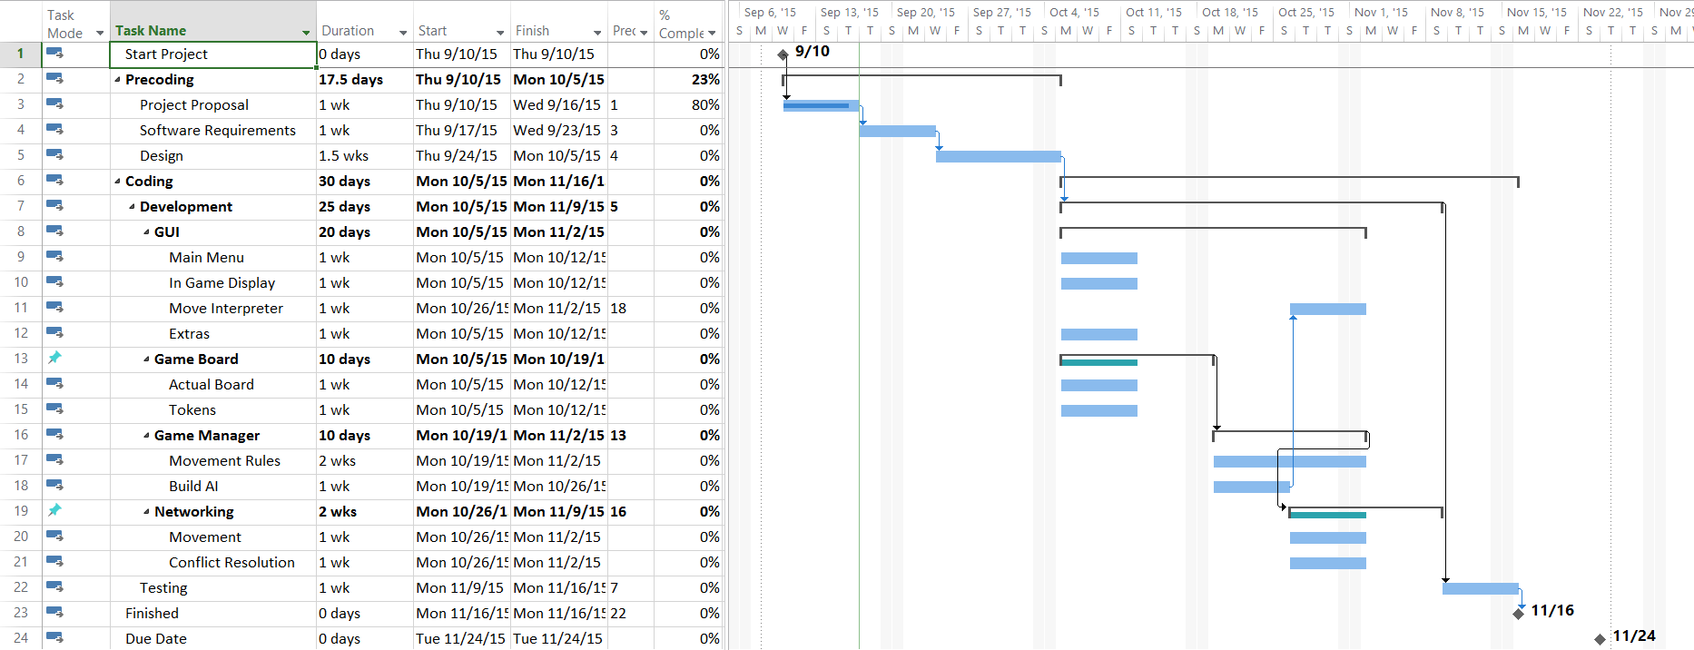

# Risks

Sickness

*Likelihood:* High

*Severity:* Low

*Consequences:* Slow Progress

*Mitigation strategy:* Plan to finish with reserve time

Failure to provide networking framework

*Likelihood:* Low

*Severity:* High

*Consequences:* Cannot finish project according to specifications

*Mitigation strategy:* Pester instructor

Teammate dropping class

*Likelihood:* Low

*Severity:* Medium

*Consequences:* Work will need to be reassigned

*Mitigation strategy:* Blood pact

Messing up Github master repo

*Likelihood:* Medium

*Severity:* Low

*Consequences:* Loss of some work

*Mitigation strategy:* Appoint a Lord Of the Repos (one teammate to merge them all…)

Schedule fails to represent reality

*Likelihood:* Certian

*Severity:* Medium

*Consequences:* Won’t meet deadlines

*Mitigation strategy:* Set deadlines earlier

Star wars too distracting

*Likelihood:* Varies by team member

*Severity:* Varies by team member

*Consequences:* Too distracted to code

*Mitigation strategy:* Be done before Dec.